Formulation And Evaluation Of Polyherbal Shampoo
Ms . Yashashree Rajabhau Bedre

Sr. No. | Content | Page No.
 | Index of Tables | ii
 | Abstract | iii
Chapter-I | Introduction | 1
Chapter-II | Literature review | 2
Chapter-III | Materials & Methodology | 3
Chapter-IV | Physiochemical Test | 18
Chapter-V | Result | 19
Chapter-VI | Conclusion | 20
Chapter-VII | References | 21

INDEX

i
Sr No. | Name of Table | Page No.
1 | Table of Ingredients | 17

TABLE OF CONTENT

ii

Abstract:
The aim was to formulate an herbal liquid shampoo containing natural ingredients with an emphasis on safety and efficacy, which will avoid the risk posed by chemical ingredients. It clears sebum, dirt, dandruff, promotes hair growth, strengthens and darkens the hair. Moreover, it also acts as conditioning agents and performs all these actions without affecting or damaging hair. The herbs shikakai, ritha, amala, aloevera powder have been selected to formulate the herbal shampoo powder on the basis of the traditional system and scientific justification with modern uses. Shampooing is the most widely recognized type of hair treatment. Shampoos are fundamentally been items pointed toward purging the hair and scalp. In the current situation, it appears to be far-fetched that natural cleanser, albeit preferable in execution and more secure over the engineered ones, will be famous with the purchasers. A more extreme methodology in promoting home grown cleanser is change the purchaser assumptions from a cleanser, with accentuation on wellbeing and viability. We have assessed and analysed the home grow cleanser, which was figured out in
past review, with two promoted shampoos. The discoveries of this examination uncover that engineered additives have once in a while been the reason for antagonistic impacts among shoppers. We have utilized the physio-substance way to deal with conservation and by planning a self-safeguarding cleanser, have stayed away from this hazard presented by substance additives. In any case, the tasteful traits, like foam and lucidity, of the lab cleanser are not equivalent with the advertised shampoos. The froth volume was on a standard. Albeit the retail items were not passage so well in the tests led by us, they appreciate market prominence, particularly in the event that they froth well This is basically due to the misleading thought among customers that 'a cleanser that froths well, functions admirably', and no genuine exertion with respect to makers to counter this error. The figured out home grown cleanser was clear and engaging. It showed great purging and detergency, low surface strain, little air pocket size and great froth dependability after 5 min.
Keywords: Herbal shampoo, ritha, aloevera, Amla, safety, efficacy, hair growth.

iii
Introduction:
Natural beauty care products are ready by the relationship of bioactive fixings and drug items. The presence of number of photochemical and botanicals in the home grown items have double importance, one that they are utilized as beauty care products for body care and one more that photochemical work on the organic elements of human body normally brings about solid skin and hairs. As the name proposes, the home grown separates implies the concentrates of spices. It is an old procedure in light of the fact that its starting point was found from the heavenly Vedas and in Unani sacred texts. As the acknowledgment said that the substance prescriptions are not necessarily fill in as sorcery shots and they might make side impacts. The latest thing advances toward the herbalism and utilization of regular items. Indian spices are the most extravagant source to be utilized in superficial ventures. Natural beauty care products were acquiring huge interest on the planet market. There is a wide scope of natural corrective items utilized as excellence system to fulfill the motivation behind beautification. Assessment of shampoos involves the quality control tests counting visual evaluation and physiochemical controls like pH, thickness and consistency. Sodium lauryl sulfate based cleansers are the most widely recognized however the fixation will change significantly from one brand to another and, surprisingly, inside a maker's item range. Modest shampoos might contain a high cleanser fixation while costly shampoos might contain very little of a modest cleanser. Shampoos for sleek hair can have the very same cleanser at similar fixation as shampoos for dry hair. The thing that matters is bound to be a decreased sum of oil or molding specialist in the cleanser for slick hair or the distinction might try and simply be the bundling. Herbal shampoos are shampoos infused with extracts of natural ingredients. The best thing about these shampoos is that they yield the best and long-lasting results. These Shampoos are free of harsh chemicals and cause no damage to the hair.(6) Herbal Shampoos are cosmetic preparations that involve the usage of traditional ayurvedic herbs to clean the scalp and the hair.
Literature Review:

- Pawan Maurya et.al (2021): The shampoo was formulated by admixing the equal amount of the aqueous extracts of all ingredients with soap nut.

- Dheeraj Pal et.al (2021): In the clinical study the organism was isolated scalp from scalp of person suffering from dandruff and maintained on sabourad’s media.

- Sutar Manisha et.al.(2013): Formulated apolyherbal shampoousing amla fruit, hibiscus leaf, neem leaf, shikakai fruit, aloe leaf, henna leaf, ritha fruit and evaluated for organoleptic, powder characteristics, dirt dispersion, wetting time, foam test and physical evaluation and considered as safe.

- Swati Deshmukh et.al.(2013): Formulated a herbal shampoo using aloevera, neem, shikakai, ritha, amla, brahmi and evaluated and concluded as safe.

- Suriya Prakash etal.(2011): Formulated a herbal shampoo for its antimicrobial and anti lice activity. The natural ingredients used are neem leaf, thulasi leaf, mehandi leaf and gooseberry fruit. The prepared formulation were evaluated for its physicochemical properties, antimicrobial and anti lice activity, which was compared with the marketed products.

- Gholamreza Dehghan et.al.(2011): Formulated a herbal conditioner shampoo using fenugreek seeds methanol extract and evaluated for physicochemical properties. It is concluded that the formulated shampoo has a good quality of introducing it to the market.
Acquisition of materials:
- Shikakai
- Amla
- Ritha
- Flaxseed
- Babchi
- Tea tree oil
- Lavender Oil
- Nagarmotha(6)
- Maca
- Aloevera
- Water

- SHIKAKAI:

Synonym: Soap -pod, Acacia concinna.

Biological source:
It is the dried gummy exudation of stem and branches of Acacia Arabica Family: Leguminosae.

Organoleptic characters:

Colour - Dark brown
Odour - Odourless
Taste - Pungent

Chemical constituents:
- It principally consists of arabin, which is a complex mixture of calcium, magnesium and potassium salts of Arabic acid.
- Arabic acid upon hydrolysis give L-arabinose, L-rhamnose, D-galactose and D-glucuronic acid.(1)
- It also contains oxidase and peroxidase enzyme.
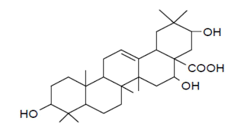

Uses:
- It is traditionally used in a shampoo preparation for hair growth.(2)
- Soothes Scalp.
- Fights Dandruff. Shikakai also has antifungal properties that help curb dandruff.(4)
- Nourishes hair follicles.

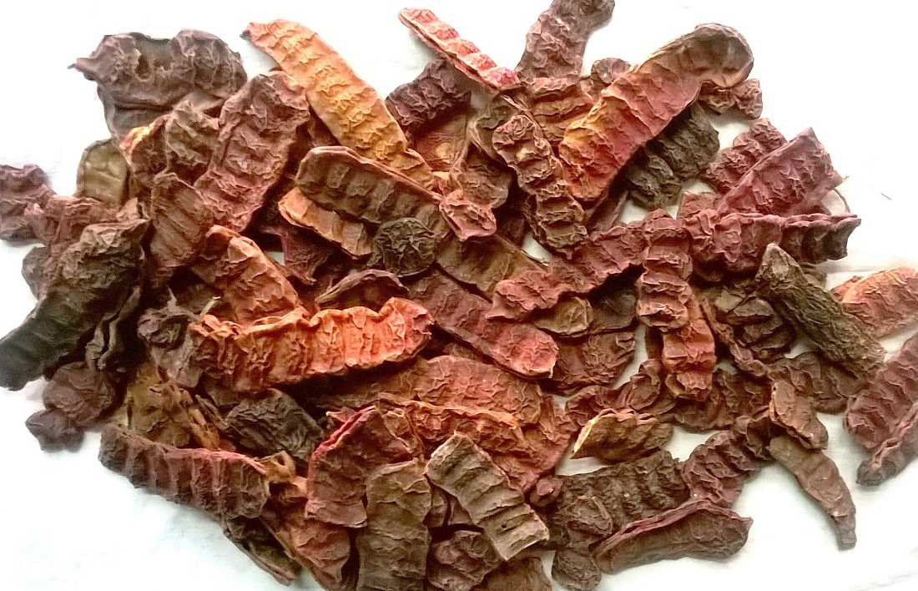

B. AMALA:

Synonym:
Indian gooseberry, Amalki.

Biological source:
It consists of dried as well as fresh fruits of the plant Embica officinalis Linn
Family - Euphorbiaceae.

Organoleptic characters:

Colour - The green color change to yellow or brick red at maturity.
Odour - Odourless
Taste - Sore and astringent
Shape - Fruits are depressed, globular

Chemical constituents:
- It is rich natural source of vitamin C.
- Fruits contain 0.5% fat, phyllemblin and 5% tannin.
- It also rich in mineral matters like phosphorus, iron and calcium.
- The fresh fruit contain 75% moisture.

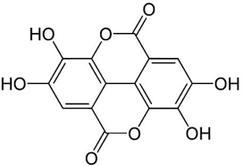

Uses:
- It provides natural protein.
- It is used as an acrid, diuretics, refrigerant and laxative.
- They are also administered in jaundice, dyspenia and anemia along with iron compound.
- Fruits are also used in preparation of inks, hair oil and shampoo.

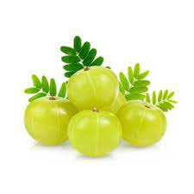

C. RITHA

Synonym:
Soap nut, Aritha, Indian soapberry.

Biological source:
It consist of the dried as well as fresh fruits of the species Sapindus mukorossi (8)
Family- Sapindaceae

Organoleptic character:

Colour - Brick red
Odour - Aromatic
Taste - Pungent
Shape - Circle
Size - 1 to 2 cm

Chemical constituents:
- Seeds of Sapindus mukorossi contain 23 % oil of which 92 % is triglycerides.
- Fruits and roots contain triterpenoid saponins named Sapindoside A&B.(7)
- Fruits also contain sesquiterpenoidal glycosides and six different fatty ester of tetracyclic triterpenoids.(3)

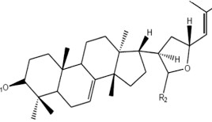

Uses:
- Cleanses the skin of oily secretion and is even used as a cleanser for washing hair.
- Seeds of Sapindus mukorossi are used in Ayurvedic medicine to remove tan and freckles from the skin.(10)
- Sapindus mukorossi can also be used as a natural remedy for many health problems, such as for treating migraine headaches.
- It is widely used in Ayurveda for poison case.
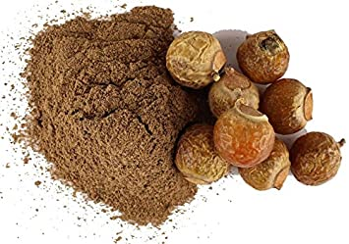

D. ALOEVERA:

Synonym: Aloe vulgairis Lamarek.

Biological Source:
Aloe is the dried juice collected by incision, from the bases of the leaves of various species of Aloe(11). Aloe perryi Baker, Aloe vera Linn or Aloe barbadensis Mil and Aloe ferox Miller. Family: Liliaceae.

Organoleptic character:

Colour - Colourless
Odour - Odourless
Taste - Slightly bitter

Chemical Constituents:
- The most important constituents of Aloes are the three isomers of Aloins, Barbaloin, β-barboloin and Isobarbaloin, which constitute the so-called ‘crystalline’ Aloin, present in the drug at from 10 to 30%.
- Other constituents are amor-phous Aloin, resin, emodin and Aloe-emodin. Barbaloin is present in all the varieties; it is slightly yellow coloured, bitter, water soluble, crystalline glycoside.
- Isobarbaloin is a crystalline substance, present in Curacao aloe and in trace amount in Cape aloe and absent in Socotrine and Zanzibar aloe.
- The chief constituents of Socotrine and Zanzibar aloe are Barbaloin and β-Barbaloin.

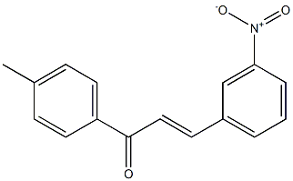

Uses:

- It has purgative property.
- It is used to treat painful inflammatory manifestations.
- It is used as an ingredient in the preparation of compound tincture of benzoin.
- Aloe gel is used to treat and cure radiation burns to get immediate relief from itching, pains.
- It helps to improve flexibility.
- It generates movement of bowel in the condition of constipation.
- Helps to heal insect bites, rashes, sores, and fungal infection.
- It is used to treat herpes and urticaria and conjunctivitis.
- It is used to treat vaginal infection and allergic reactions.
- Its boiled juice is used to treat hair fall(12).
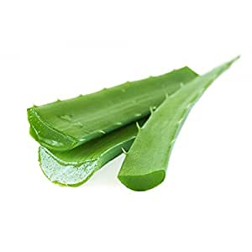

E. FLAXSEED:
Synonyms:
Linseed, alsi (Hindi).

Biological Source:
Linseed is the dried, ripe seed of Linum usitatissimum Linn. Linseed oil is obtained by expression of linseeds. Family Linaceae.

Chemical Constituents:
- Linseed contains fixed oil (30–40%), mucilage (6–10%), protein (25%) (linin and colinin), small amount of enzyme lipase, and linamarin which is a cyanogenetic glycoside.
- Unripe seeds contain starch which is converted to mucilage on ripening the seeds. The mucilage can be fractionated into a neutral fraction a remified, arabinoxylan composed of D-xylose, -arabinose, -glucose and -galactose; and an acidic fraction mainly composed of L-rhamnose and D-galactose.
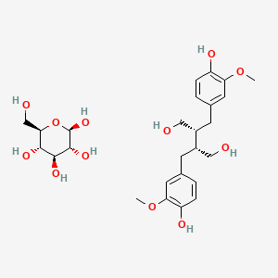

Uses:
- Linseed is used as demulcent and in form of poultices for gouty and rheumatic swellings.
- Natural hair tamer (24).
- Internally it is used for gonorrhoea and irritation of the genito-urinary system. Linseed oil has emollient, expectorant, diuretic, demulcent, and laxative properties and is utilized externally in lotions and liniments.
- Non-Staining iodine ointment soap, linoleum, greases, polishes, polymers, varnishes, paints, putty, oil cloths, printing inks, artificial rubber, tracing cloth, tanning and enamelling leather, etc. are also prepared from Linseed oil.
- The mucilaginous infusion is used internally as a demulcent in colds, coughs, bronchial affections, inflammation of the urinary tract, gonorrhoea, and diarrhoea.

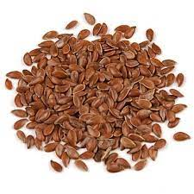

F. TEA TREE (Essential Oil):

Synonym: Melaleuca alternifolia.
Biological source: The leaves of the tea tree.
Family: Myrtaceae

Organoleptic properties:
Colour - Clear, mobile liquid
Taste - Earthy, spicy odor
Solubility - Sparingly soluble in water
Chemical Constituents:
The major constituents of commercial TTO are terpinen-4-ol, γ-terpinene, 1,8-cineole, α-terpinene, α-terpineol, p-cymene, and α-pinene(28).
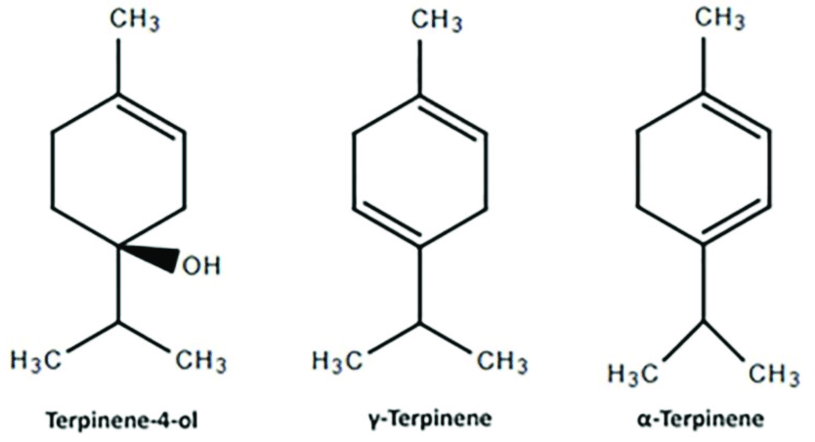

Uses:
- Anti-inflammatory(27).
- Antifungal(26)
- Antiviral.
- Acne.
- Athlete's foot.
- Contact dermatitis(25).
- Dandruff and Cradle Cap.
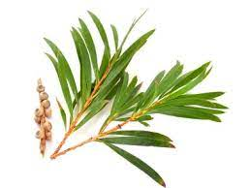

G. LAVENDER (Essential Oil ):
Biological source:
Distillation from the flower spikes of certain species of lavender.
Family: Lamiaceae
Synonym: Lavandula angustifolia.
Chemical constituents:
Composed of linalyl acetate (3,7-dimethyl-1,6-octadien-3yl acetate), linalool (3,7-dimethylocta-1,6-dien-3-ol), lavandulol, 1,8-cineole, lavandulyl acetate, and camphor.
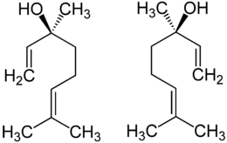
Use:
- It soothes angry skin and can help with bug bites(29).
- It may help prevent hair loss(30).
- Treats insomnia.
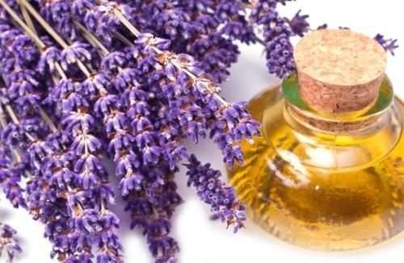

H. BRAHMI:
Synonym: Kapotvadka, Somvalli and Saraswati
Biological Source:
Fresh or dried herb of Centella asiatica (L.)
Family: Umbelliferae
Chemical Constituents:
Hersaponin, apigenin, D-mannitol, monnierasides I-III, plantainoside B and cucurbitacin.
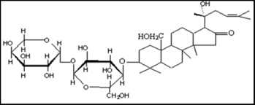
Uses:
- Analgesic property.
- Hair growth(18).
- Anti-inflammatory property.
- Anti-microbial property.
- Anti-convulsant property
- Anti-depressant property(17).
- Anxiolytic property (reduces anxiety).
- Anti-neoplastic property.
- Antioxidant property.
- Liver protective property.
- Immunostimulatory property.

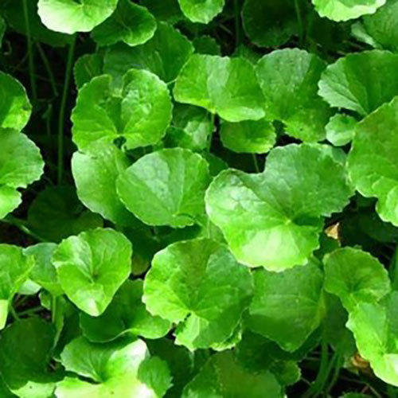

I. NAGARMOTHA:
Synonym: Nut grass, Nut sedge, Java grass.
Biological source: It is rhizome.
Family: Cyperacea
Chemical Constituents:
Cyperene, longifolin, caryophylline oxide and longiverbenone.(22)

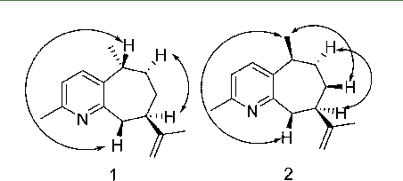

Use:
- Controls hair fall associated with dandruff.(21)
- Has pitta balancing property.
- Fungicidal property (23).

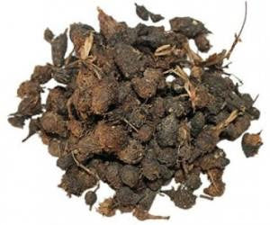

J. MACA:
Synonym: Lepidium meyenii.
Biological source: Edible herbaceous biennial plant.
Family: Brassicaceae
Chemical Constituents:
There are several kinds of chemical constituents with bioactivity in Maca, including glucosinolates, macamides, macaenes, thiohydantoins, and alkaloids(35).
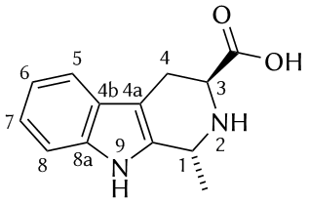
Uses:
- Stimulate the scalp, thereby boosting the amount of nourishment that reaches hair follicles.
- Boosting energy and endurance.(37)
- Reducing blood pressure.
- Reducing sun damage.
- Maca helps to reduce the effects of ageing, and gives new strength to the skin.(36)
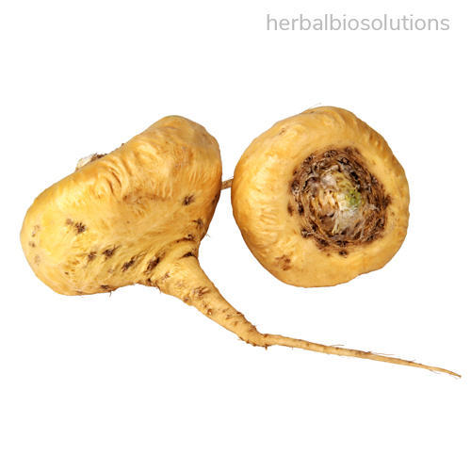
K. BABCHI:
Synonym: Bakuchi.
Biological source: It is a seed.
Family: Fabaceae
Chemical Constituents:
A Flavonoids – IBC
Use:
- Bakuchi powder help improves hair growth and controls dandruff when applied externally due to its Keshya property(14).
- Seeds have been used to manage various skin diseases like leucoderma, a condition of discolouration of the skin.
- Helps in vitiligo(15).

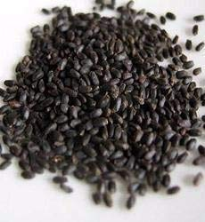

L. FENUGREEK:
Synonym: Methi.
Biological Source: Annual plant can be used whole except root.
Family: Leguminosae
Chemical Constituents:
Amino acids: 4-Hydroxyisoleucine, 4hydroxyisoleucine lactone, arginine, histidine, and lysine.
Alkaloids: Trigonelline, gentianine, and carpaine.
Flavonoids: Apigenin, luteolin, orientin, quercetin, vitexin, and isovitexin.
Carbohydrates: Mainly mucilage.
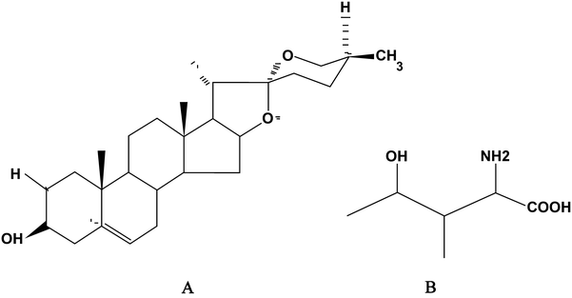

Use
- Used as a tonic, demulcent, aphrodisiac.
- Aromatic. (40)
- Carminative.
- Hypoglycaemic properties.
- Powder, if taken internally, to control blood cholesterol level.
- Used as a condiment and for flavouring food preparation.
- Used in ointments, plasters, and poultices.
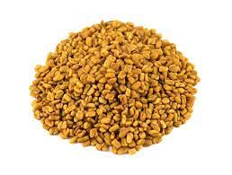
Methodology:

INGREDIENT | QUANTITY
Shikakai | 2 gm
Amla | 2 gm
Ritha | 5 gm
Flaxseed | 10 gm
Babchi | 2 gm
Nagarmotha | 2 gm
Maca | 2 gm
Brahmi | 2 gm
Fenugreek | 1 gm
Tea tree oil | 1 ml
Lavender oil | 1ml
Water | Q.S.

- Weigh the ingredients.
- Triturate the ingredients.
- Mix the ingredients.
- Add 400ml of water and boil until it comes 1/4th of it.
- Boil flaxseed in another beaker with sufficient amount of water.
- Let it boil until it get thick.
- Mix the two mixtures.
- Pour them into container with muslin cloth.
- Add essential oil.
- Shake the container.
- Close the lid tightly.
- Keep the container in normal refrigerator temperature.

Storage Conditions :

- Glass or plastic container with pack lid.
- Normal refrigerator temperature 4°C (40°F) .
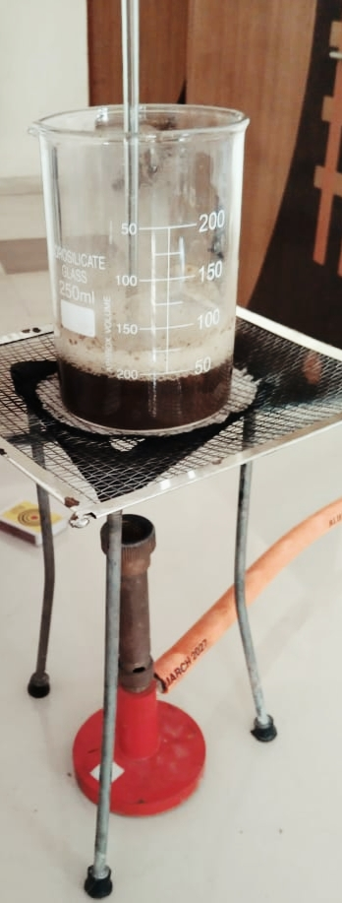
Physiochemical Evaluation:

- Determination of Clarity, Colour and Odours:

Clarity and colour were checked by naked eyes against white background, the odour was pleasant.

- Determination of PH:

10ml of shampoo was weighted accurately in a 100ml beaker 40ml water was added and dispersed the soap in it. The pH of the solution is determined by using pH paper which is neutral.

- Foam Height:

10ml of sample shampoo was taken dispersed in 100ml distilled water. Then transferred it into 100ml measuring cylinder; volume was made given and stand till aqueous volume measured the foam height, above the aqueous volume.

- Foam Retention:

20mL of sample shampoo was taken into a 100ml graduated measuring cylinder. The cylinder was covered with hand and shaken 10 times. The volume of foam at 1-minute intervals for 4 minutes was recorded.

- Thermal stability:

This shampoo is mainly stable at room temperature while using . Storage is at refrigerator temperature.

- Dirt dispersion test:

Two drops of shampoo were added to 10ml of distilled water taken in a large test tube. To this solution, one drop of India ink was added and the test tube was stoppered and shaken ten times. The amount of ink in the foam was indicated by the rubric such as None, Light, Moderate or Heavy .

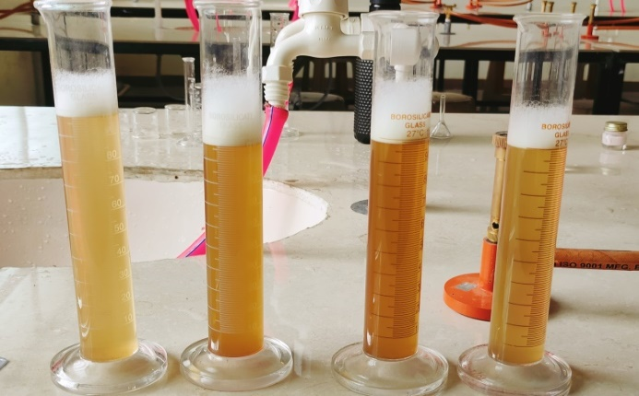

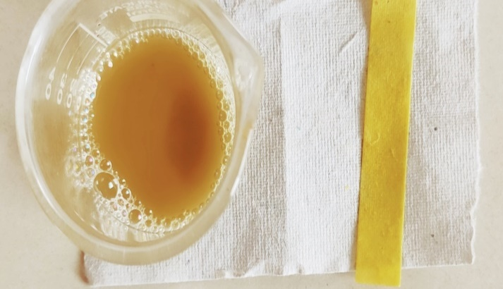
Result:
Herbal shampoo formulation:
The shampoo was formulated by admixing the equal amount of the powder extracts of all the ingredients with Ritha. The above plant extract contains phytoconstituents like saponins which is a natural surfactant having detergent property and foaming property. An ideal shampoo must have adequate viscosity and many natural substances possess good viscosity. The Flaxseed acts as a thickening agent. Tea tree oil (1 ml) added to preserve the shampoo as a anti-microbial agent. Lavender oil is used to mask-up the herbal smell.
Conclusion:
The results obtained during experimentation clearly indicate a promising formulation of quality enhanced herbal shampoo with a unique aroma, colour, and potential for cleaning and foaming ability The point of this study was to form a totally natural cleanser which is at standard with the engineered cleanser benefit capable on the lookout. We formed a home-grown cleanser by utilizing
plant removes which are regularly utilized generally and lauded for their hair purging activities across Asia. All the fixings used to form cleanser are more secure than Sili-cones and polyquaterniums engineered moulding specialists
what's more, versus can enormously diminish the hair or protein misfortune during brushing. Rather than utilizing cationic conditioners we have utilized
Sheekakai, Amla, Flaxseed and other plant concentrates to give the moulding impacts. A few tests were performed to assess and look at the physicochemical properties of both arranged and showcased shampoos. The current review was done fully intent on setting up the natural cleanser that decreases balding during brushing, more secure than the substance moulding specialists as well as to reinforce the hair development. Home grown cleanser was formed with the watery concentrate of restorative plants that are usually utilized for purging hair customarily. Utilization of moulding specialists (manufactured) diminishes the protein or balding. To give the powerful moulding impacts, the current review includes the utilization of shikakai, amla, and other plant removes rather than synthetic cationic conditioners. The primary reason behind this examination was
to foster a stable and practically viable cleanser by barring a wide range of manufactured added substances, which are regularly consolidated in such plans. To assess for good item execution of the arranged cleansers, many tests were performed. Our pre-arranged cleanser showed practically identical outcome
with that of showcased cleanser for quality control tests yet further innovative work is expected to work on its overall quality.
Reference:

- Khanpara K, Renuka V, Harisha C. A detailed investigation on shikakai (Acacia concinna Linn.) fruit. J. Curr. Pharm. Res. 2012;9:6-10.
- Templeton RH. Reetha and shikakai as natural surfactants for cleaning of historic textiles. Int J Res Analyt Rev. 2018;5:2348-50.
- Paria S, Biswal NR, Chaudhuri RG. Surface tension, adsorption, and wetting behaviors of natural surfactants on a PTFE surface. Aiche journal. 2015 Feb;61(2):655-63.
- Medisetti V, Battu GR, Sheik PB, Samineni S, Ruthala P, Pothula R. Antibacterial and Anthelmintic Activities of Aqueous and Alcoholic Extracts of Acacia concinna (Shikakai) Pods. Inventi Rapid: Ethnopharmacology. 2017;2017(3).
- Preethi PJ, Padmini K, Srikanth J, Lohita M, Swetha KP, Rao PV. A review on herbal shampoo and its evaluation. Asian journal of pharmaceutical analysis. 2013;3(4):153-6.
- Sharma L, Agarwal G, Kumar A. Medicinal plants for skin and hair care.
- Biswal NR, Paria S. Interfacial and wetting behavior of natural–synthetic mixed surfactant systems. RSc Advances. 2014;4(18):9182-8.
- Sur UK, Ankamwar B, Karmakar S, Halder A, Das P. Green synthesis of Silver nanoparticles using the plant extract of Shikakai and Reetha. Materials Today: Proceedings. 2018 Jan 1;5(1):2321-9.
- Govindarajan M, Jebanesan A, Reetha D, Amsath R, Pushpanathan T, Samidurai K. Antibacterial activity of Acalypha indica L. Eur Rev Med Pharmacol Sci. 2008 Sep 1;12(5):299-302.
- Shankar J, Ranjan R, Nik Ilieva G, Joshi H. Amla Powder. Ayurvedic Preparation. 2010 Sep 10.
- Mirunalini S, Vaithiyanathan V, Krishnaveni MA. Amla: a novel ayurvedic herb as a functional food for health benefits-a mini. Int J Pharma Pharmaceut Sci. 2013;5.
- Mirunalini S, Krishnaveni M. Therapeutic potential of Phyllanthus emblica (amla): the ayurvedic wonder. Journal of basic and clinical physiology and pharmacology. 2010 Feb 1;21(1):93-105.
- Mj A, Singh TR, Patgiri BJ. Anti microbial activity of different dosage forms of Bakuchi (Psoralea corylifolia Linn.) taila, an Ayurvedic formulation. International Journal of Ayurvedic Medicine. 2015;6(3):232-6.
- Uikey SK, Yadav AS, Sharma AK, Rai AK, Raghuwanshi DK, Badkhane Y. The botany, chemistry, pharmacological and therapeutic application of Psoralea corylifolia L.-A review. International Journal of Phytomedicine. 2010 Apr 1;2(2).
- Bankar SA, Girbide SG, Reddy AP, Damle RV, Kachare KB, Parade AB. Management of Shwitra wsr to vitiligo with bakuchi churna and bakuchi tail: a case study. World Journal of Pharmaceutical Research. 2016 Oct 5;5(12):1066-71.
- Pandey P, Mehta R, Upadhyay R. Physico-chemical and preliminary phytochemical screening of Psoralea corylifolia. Archives of Applied Science Research. 2013;5(2):261-5.
- Roodenrys S, Booth D, Bulzomi S, Phipps A, Micallef C, Smoker J. Chronic effects of Brahmi (Bacopa monnieri) on human memory. Neuropsychopharmacology. 2002 Aug;27(2):279-81.
- Banerjee PS, Sharma M, Nema RK. Preparation, evaluation and hair growth stimulating activity of herbal hair oil. J Chem Pharm Res. 2009;1(1):261-7.
- Rao YM, Sujatha P. Formulation and evaluation of commonly used natural hair colorants.
- Purwal L, Gupta SP, Pande SM. Development and evaluation of herbal formulations for hair growth. E-Journal of Chemistry. 2008 Jan 1;5(1):34-8.
- Imam H, Sofi G, Seikh A, Lone A. The incredible benefits of Nagarmotha (Cyperus rotundus). International Journal of Nutrition, Pharmacology, Neurological Diseases. 2014 Jan 1;4(1):23.
- Srivastava RK, Singh A, Srivastava GP, Lehri A, Niranjan A, Tewari SK, Kumari K, Kumari S. Chemical constituents and biological activities of promising aromatic plant nagarmotha (Cyperus scariosus R. Br.): A review. InProc Indian Natn Sci Acad 2014 Sep (Vol. 80, No. 3, pp. 525-536).
- Dubey N, Gupta RL, Raghav CS. Study of yield, quality and fungicidal properties of Nagarmotha oil. Pesticide Research Journal. 2011 Dec;23(2):185-9.
- Manjula D, Jenita JJ, Premakumari KB, Shanaz B. Formulation and evaluation of flaxseed hair gel: a natural hair tamer. International Journal of Research in Pharmacy and Chemistry. 2018;8(3):487-91.
- Pazyar N, Yaghoobi R, Bagherani N, Kazerouni A. A review of applications of tea tree oil in dermatology. International journal of dermatology. 2013 Jul;52(7):784-90. Hartford O, Zug KA. Tea tree oil. Cutis. 2005 Sep 1;76(3):178-80.
- Cavanagh HM, Wilkinson JM. Biological activities of lavender essential oil. Phytotherapy research. 2002 Jun;16(4):301-8.
- Preethi PJ, Padmini K, Srikanth J, Lohita M, Swetha KP, Rao PV. A review on herbal shampoo and its evaluation. Asian journal of pharmaceutical analysis. 2013;3(4):153-6.
- Al Badi K, Khan SA. Formulation, evaluation and comparison of the herbal shampoo with the commercial shampoos. Beni-Suef University Journal of Basic and Applied Sciences. 2014 Dec 1;3(4):301-5.
- Gubitosa J, Rizzi V, Fini P, Cosma P. Hair care cosmetics: From traditional shampoo to solid clay and herbal shampoo, a review. Cosmetics. 2019 Feb 19;6(1):13.
- Dubey S, Nema N, Nayak S. Preparation and evaluation of herbal shampoo powder. Ancient science of life. 2004 Jul;24(1):38.
- McCage CM, Ward SM, Paling CA, Fisher DA, Flynn PJ, McLaughlin JL. Development of a paw paw herbal shampoo for the removal of head lice. Phytomedicine. 2002 Jan 1;9(8):743-8.
- Patel IM, Talathi AD. Use of traditional Indian herbs for the formulation of shampoo and their comparative analysis. Int. J. Pharm. Pharm. Sci. 2016;8(3):28-32.
- Azadbakht M, Monadi T, Esmaeili Z, Chabra A, Tavakoli N. Formulation and evaluation of licorice shampoo in comparison with commercial shampoo. Journal of Pharmacy & Bioallied Sciences. 2018 Oct;10(4):208.
- Singh SR, Phurailatpam AK, Senjam P. Identification of plant use as natural herbal shampoo in Manipur. African Journal of Traditional, Complementary andAlternative Medicines. 2014;11(1):135-9.
- Yadav AR, Mohite SK. Formulation and evaluation of antidandruff shampoo. Research Journal of Topical and Cosmetic Sciences. 2020 Jul 1;11(2):55-8.
- Gholamreza DN, Fariba S, Payam K, Ehsan M, Javad J. Formulation of herbal conditioner shampoo by using extract of fenugreek seeds and evaluation of its physicochemical parameters. African journal of pharmacy and pharmacology. 2011 Dec 15;5(22):2420-7.
- Cavanagh HM, Wilkinson JM. Lavender essential oil: a review. Australian infection control. 2005 Mar 1;10(1):35-7
- Cox SD, Mann CM, Markham JL, Gustafson JE, Warmington JR, Wyllie SG. Determining the antimicrobial actions of tea tree oil. Molecules. 2001 Jan 16;6(2):87-91.

